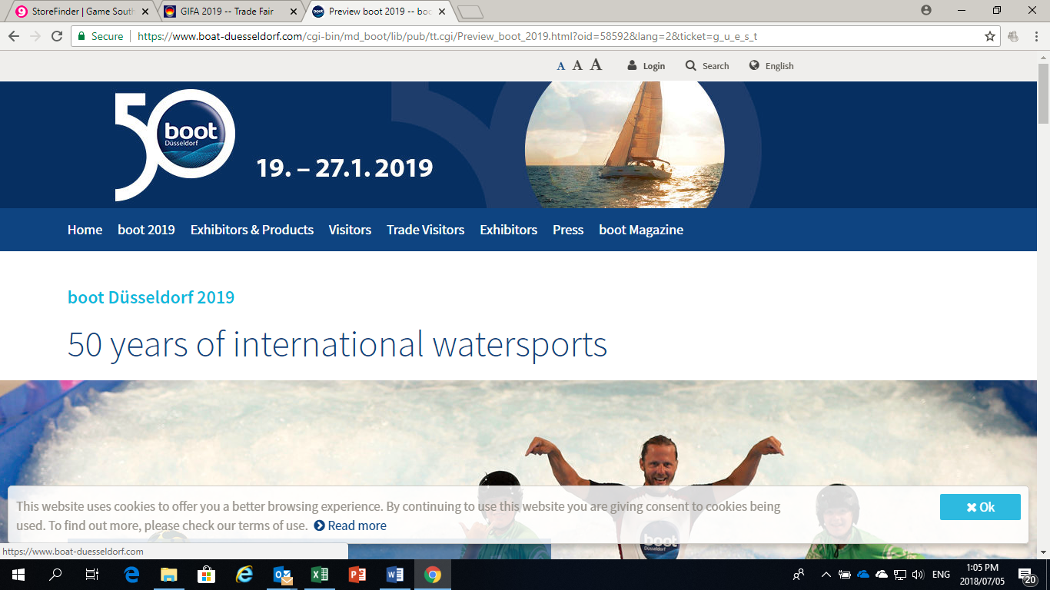

**Order Form – boot 2019**

**19 – 27 January 2019 in Düsseldorf, Germany**

**Please fill in your company details and send it back to:**

Email: ticketsales[@germanchamber.co.za](mailto:ameyer@germanchamber.co.za)

JHB Fax : +27 (0)86 677 8762

CPT Fax : +27 (0)21 424 3324

**Please indicate the number of entrance tickets below:**

|  |  |
| --- | --- |
| Choose an item.: One-day tickets* @ R390.- | Choose an item.: Two-day tickets* @ R520.- |

*\*The admission tickets to* ***boot 2019***  *entitle the holder to free travel on public transport within the network of the VRR (Verkehrsverbund Rhein-Ruhr) transport authority* [*www.vrr.de/en/*](http://www.vrr.de/en/)*.*

*\*\* Catalogues included in entrance fee and available on the fairgrounds.*

|  |  |  |  |  |  |  |  |  |  |  |
| --- | --- | --- | --- | --- | --- | --- | --- | --- | --- | --- |
| **Company:** | | | | Click here to enter text. | | **Position:** | | | Click here to enter text. | |
| **Title:** |  | | **Name:** | | Click here to enter text. | | **Surname:** | | | Click here to enter text. | |
| **Postal**  **Address:** | | Click here to enter text. | | | | **Code:** | | Click here to enter text. | | |
| **City:** | Click here to enter text. | | | | | **VAT#:** | | Click here to enter text. | | |
| **Tel:** | Click here to enter text. | | | | | **Fax:** | | Click here to enter text. | | |
| **Email:** | Click here to enter text. | | | | | **Web:** | | Click here to enter text. | | |

* Ticket sales and collections are strictly from Monday to Friday between 08h00 and 15h00.
* **Payment only possible by EFT bank transfer to SA-German Chamber of Commerce and Industry.**
* Invoice will only be made after payment has been received.
* Cancellation fee of 15% on refunded tickets shall be payable.
* Tickets not refundable once stamped by the German Consulate.
* Tickets cannot be refunded once the fair has commenced.
* Ticket prices do not include bank transfer fees.
* **Please note: ticket prices are invariable, include admin fees and are converted into Rands using the exchange rate of the day of creation of this document.**
* Online tickets are available.

**The Southern African–German Chamber of Commerce and Industry:**

**Ticket Sales**

|  |  |  |  |  |
| --- | --- | --- | --- | --- |
| **Johannesburg Office:** | | | **Cape Town Office:** | |
| Ms. Thoko Mazibuko | | | Mr. Thomas Kallenbach | |
| Tel: +27 (0)11 486 2775 | | | Tel: +27 (0)21 422 5577 | |
| Fax: +27 (0)86 677 8762 | | | Fax: +27 (0)21 424 3324 | |
| Email: [tmazibuko@germanchamber.co.za](mailto:tmazibuko@germanchamber.co.za) | | | Email: [tkallenbach@germanchamber.co.za](mailto:tkallenbach@germanchamber.co.za) | |
| 47 Oxford Road, Forest Town, 2193  (Entrance Waltham Rd.) | | | Unit 402, 4h Floor  42 Keerom Street, Cape Town, 8001 | |
| PO Box 87078, Houghton, 2041 | | | PO Box 1272, Cape Town, 8001 | |
| **Banking Details:** | **SA-German Chamber of Commerce & Industry**  **Nedbank Braamfontein** | | |  | |
|  | **Branch Code:** | **1950 05** | | | |
|  | **Account-No: Reference:** | **1950-459349**  **“Your company name”** | | | |

